Environmental Management System Manual

Cadillac Hertz Team JOTA
Stubby Grove Farm
Bells Yew
Green TN3 9BT

Tel: 01892 752067
Website: https://jotasport.com/

Contents
Contents 2
Introduction 3
Who We Are 3
The Scope of the Environmental Management System 3
Organisation Structure 4
Context of JOTA Group 4
Interested Parties 4
Leadership Commitment 5
Management System Documentation 5
Policy 6
Manual 6
Procedures 6
Records 6

Introduction
This manual is designed to provide an overview of the Environmental Management System (EMS) developed and managed by Cadillac Hertz Team JOTA. This manual will identify the external and internal issues relevant to Cadillac Hertz Team JOTA and affect Cadillac Hertz Team JOTA’s ability to achieve intended quality and environmental outcomes. The scope of the system, including its composition, is also set out.
This EMS Manual relates to the business, processes and employees of Cadillac Hertz Team JOTA.

Who We Are
JOTA is one of the most experienced and successful endurance racing teams in the world. Having competed at the highest level of sports car racing for over a decade, the team amassed an outstanding LMP2 record including 10 podium finishes at the Le Mans 24 Hours and an unprecedented 2nd and 3rd place overall at Le Mans in 2017. Championship titles include the 2016 European Le Mans Series and the 2017 Asian Le Mans Series, with vice-championship titles in the 2017, 2018–2019, 2019–2020 and 2021 FIA World Endurance Championship.
From 2024, the team stepped up to the Hypercar class — the pinnacle of endurance racing — competing in the FIA World Endurance Championship as Cadillac Hertz Team JOTA. The team fields the Cadillac V-Series.R Hypercar in partnership with Cadillac and Hertz, continuing its ambition to compete at the front of the field at Le Mans and across the WEC calendar.

The Scope of the Environmental Management System
This document sets out the scope of the EMS of Cadillac Hertz Team JOTA as follows:
Organisation: Cadillac Hertz Team JOTA
Scope: The engineering, build, preparation and running of racing cars for competitive sport including the transport and operations at race venues worldwide.
Location: Stubby Grove Farm, Bells Yew Green TN3 9BT

Standard: FIA 3-Star Environmental Accreditation

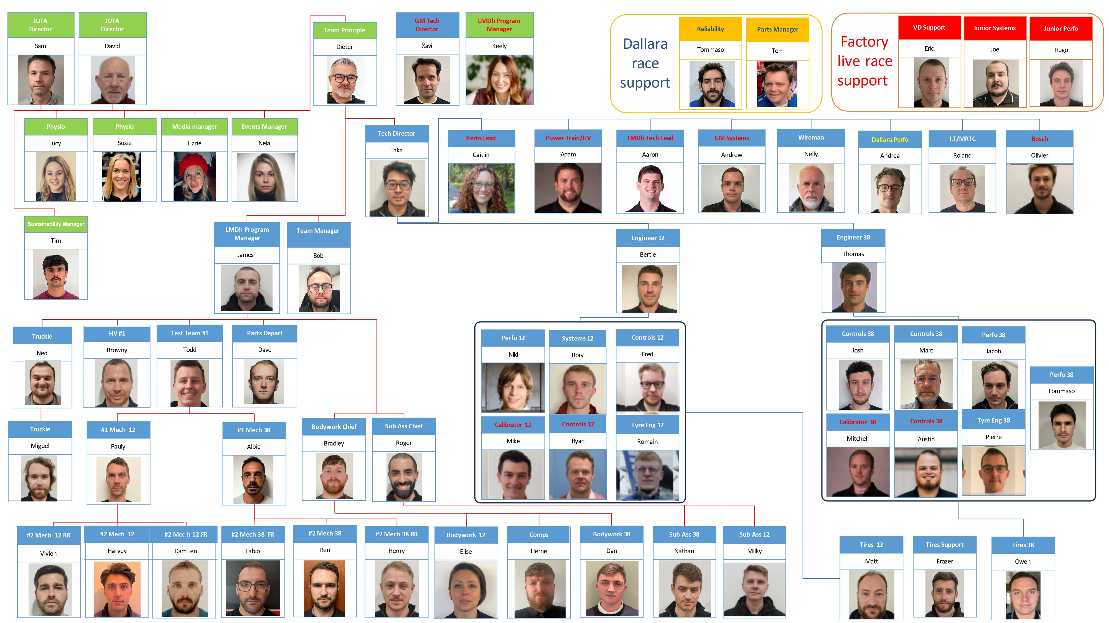Organisation Structure – EMS team highlighted with red rectangle

Context of Cadillac Hertz Team JOTA
The strategic direction of Cadillac Hertz Team JOTA is to develop a stronger Environmental performance.
The development and scope of the EMS has been aligned to the business strategy and will ensure that the business continually improves its processes through review and monitoring performance.
Cadillac Hertz Team JOTA operates in a highly competitive environment and engages with a wide selection of stakeholders, including Suppliers, Employees and Regulatory Bodies. We must ensure that our processes are comprehensively rigorous and comply with statutory and regulatory requirements whilst simultaneously offering the flexibility to incorporate a changing environmental compliance landscape and advancing technology.
Cadillac Hertz Team JOTA understands that it is responsible for mitigating its environmental impact. This impact can be direct or indirect and short or long-term. Cadillac Hertz Team JOTA has assessed its significant aspects based on its operational activities and has implemented controls to monitor, measure, and, wherever possible, manage those impacts.
In the development of this system, JOTA has planned and implemented actions to address risks and opportunities that could:
- Affect the effectiveness of the EMS.
- Affect intended results.
- Cause negative effects.
- Cause noncompliance to statutory and regulatory requirements.
- Impact on the local or wider environment.

Interested Parties
Cadillac Hertz Team JOTA identifies and reviews the needs and expectations of those parties that are concerned with or affected by its performance (the "Stakeholders"). The Risk and Opportunities Register identifies Aspects and Impacts and their controls including training, records requirements and communication. The Risk Register will be reviewed through the management meetings.
Cadillac Hertz Team JOTA has embedded a communication process throughout the EMS to ensure appropriate channels are available with all its interested parties (internal and external). These processes consider what will be communicated, when to speak, who to communicate with, and how to communicate. Internal responsibilities for communication are recorded in the Interested Parties Analysis document, which can be found in the Content section of the toolbox in this EMS.

Leadership Commitment
The Leadership Team at Cadillac Hertz Team JOTA are committed to the continual improvement of quality and environmental issues and the reduction of risk at every level the organisation.
To manage the risk and opportunities associated with their industry, process, and stakeholders, Cadillac Hertz Team JOTA has implemented a number of controls within this EMS that include:
- Environmental Aspects Register
- Legal Register
- Documenting operational procedure and associated responsibility, risks and controls.
- Documenting roles, responsibilities and resources
These controls help Cadillac Hertz Team JOTA to understand the risks and opportunities within their organisation. The Leadership Team will address these and provide sufficient resources, training, or other support to mitigate the risk and maximise the opportunity.
When involvement of the Leadership Team is required, this will be the EMS manager and the Director. The Leadership Team has specific responsibilities they are aware of and wholeheartedly support. These include:
- Taking accountability for the effectiveness of the EMS.
- Ensuring that all personnel acting on behalf of Cadillac Hertz Team JOTA are aware of their responsibility to support the EMS. The associated controls for these are defined within the EMS.
- Ensuring that policies and objectives are established for the EMS and are compatible with the strategic direction of Cadillac Hertz Team JOTA.
- Ensuring compliance with statutory and regulatory requirements
- Ensuring the integration of the EMS requirements into JOTA’s business processes.
- Ensuring that the resources needed for the EMS are available.
- Communicating the importance of effective management and conforming to the EMS requirements.
- Ensuring that the EMS achieves its intended outcome(s).
- Directing and supporting persons to contribute to the effectiveness of the EMS.
- Promoting continual improvement.
- Supporting other relevant management roles to demonstrate their leadership as it applies to their areas of responsibility.
- Developing, leading and promoting a culture in JOTA that supports the intended outcomes of the EMS.

Performance Measurement and Objectives
Cadillac Hertz Team JOTA monitors its environmental performance through a set of Key Performance Indicators (KPIs), which are documented and tracked within the EMS Toolbox. KPIs cover all significant environmental aspects including carbon emissions, energy and water consumption, waste management, freight and transport, and sustainable procurement.
Because the number of race events in a season varies from year to year, KPI performance is assessed on both an absolute basis and a normalised basis. The primary normalisation unit is performance per race event, which allows fair comparison between seasons regardless of calendar length. Percentage-based KPIs (such as the waste recycling rate and sustainable procurement score) are self-normalising and do not require further adjustment.
The normalised baselines for all environmental KPIs are established from the 2024 reporting year and are documented in the KPI Baseline Methodology record held within the EMS evidence folder. These baselines are reviewed annually as part of the Management Review process and updated as new data becomes available.
The 2024 carbon baseline, established through the VSME sustainability reporting framework, gives a total footprint of 2,075 tCO2e (location-based), of which 95.1% is Scope 3 — indirect emissions from business travel, freight, supply chain and other upstream activities. Scope 2 market-based emissions are zero as the facility operates on a 100% renewable electricity tariff. All future carbon reduction targets are measured against this baseline.

Management System Documentation
The EMS consists of a number of documents, of which the structure is set out below. Together, these documents ensure that JOTA maintains and continually improves its commitment to the environment.
Documents relevant to the EMS are held on SharePoint.
The documents are read-only and published by the EMS Manager on behalf of Cadillac Hertz Team JOTA’s Director.

Policy
Signed by the Director, this document showcases Cadillac Hertz Team JOTA’s commitment to the environment. This policy will be communicated internally and made publicly available on request.

Manual
This Manual is the ‘Top Level’ within the EMS. This document is deliberately concise, laying out just the Scope, Context of Cadillac Hertz Team JOTA, and basic arrangements.

Procedures
The ‘Second Level’ of the Management System comprises more detailed instructions in ‘Written Procedure’ or ‘Flow Chart’ form. The purpose of these procedures is to reflect how things are done to ensure that the key processes of Cadillac Hertz Team JOTA are operated in an appropriate and consistent manner by all persons involved.
This level includes procedures detailed as mandatory by the FIA and as required to suitably control JOTA’s processes. These documents have been written to ensure that risks and opportunities, statutory regulatory requirements, and resources are considered throughout the entire operational process.
The procedures shall be made available to individuals as appropriate to the activity being undertaken and must be followed to ensure compliance with JOTA’s processes. If a procedural improvement or change is identified, this will be discussed with the EMS Manager, who will make amendments as necessary. Reference to the latest Policy, Manual and Procedures is maintained on a Master List.

Records
Each of the processes is administered through defined Operational Controls and record-keeping. This ‘Third Level’ comprises, for example, Computer Databases, Spreadsheets, and Standard Forms, Document Templates or other planning and recording systems. The purpose of these controls is to ensure that necessary information is effectively specified, communicated, and recorded. Records do not necessarily require version control due to the nature of their use. Traceability throughout the process must be maintained through the proper implementation of these control measures. The majority of records required by the standards are maintained through the Toolbox system. Control of versions is maintained via the software.
Should you require any further information on JOTA’s EMS, then please contact t.rocker@jotagroup.com.

